Qanah, Heba

Supervised by MOHANNAD ABUOBAIED

AmazingMartEU2Geo Analysis

Data Analysis and Visualization 

Table of Contents

1. Introduction 4

1.1 Summary 4

1.2 Overview 4

1.3 Datasets 4

1.4 Requirements 6

2. Solution 6

2.1 Tools 6

2.2 Components 7

2.2.1 Dashboards: 7

3. Conclusion 10

3.1 Recommendations 10

**References** 11

Table of Figures

Figure 1 7

Figure 2 7

Figure 3 9

Figure 4 10

Figure 5 11

Figure 6 12

# Introduction

## Summary

This project is aimed to get the best benefits dashboards that created using dataset and analyzing tools to help managers taking the right decision in the right time, also to be on the track with their data moving when the dashboards are user friendly that they can show multiple result from one visual, and I used power BI tool to present the Dashboards.

## Overview

Data is everywhere, and people use data every day, whether they realize it or not. Daily tasks such as measuring coffee beans to make your morning cup, checking the weather report before deciding what to wear, or tracking your steps throughout the day with a fitness tracker can all be forms of analyzing and using data, data analytics is the collection, transformation, and organization of data in order to draw conclusions, make predictions, and drive informed decision making, it requires a wide range of skills to be performed effectively such as : Structured Query Language(SQL), Statistical programming languages(Python), Statistical visualization, or the ability to use charts and graphs to tell a story with data.

## Datasets

A dataset is a range of contiguous cells on an Excel worksheet containing data to analyze, a column represents a category of information, each column has a name, a data type, a row represents an instance of data in the dataset. In this project I worked on (AmazingMartEU2Geo) dataset which include data about orders for specific organization and their related customers, the time frame is from 2011 to 2014.It include two sheets with 12 columns in the first one and 8 in the other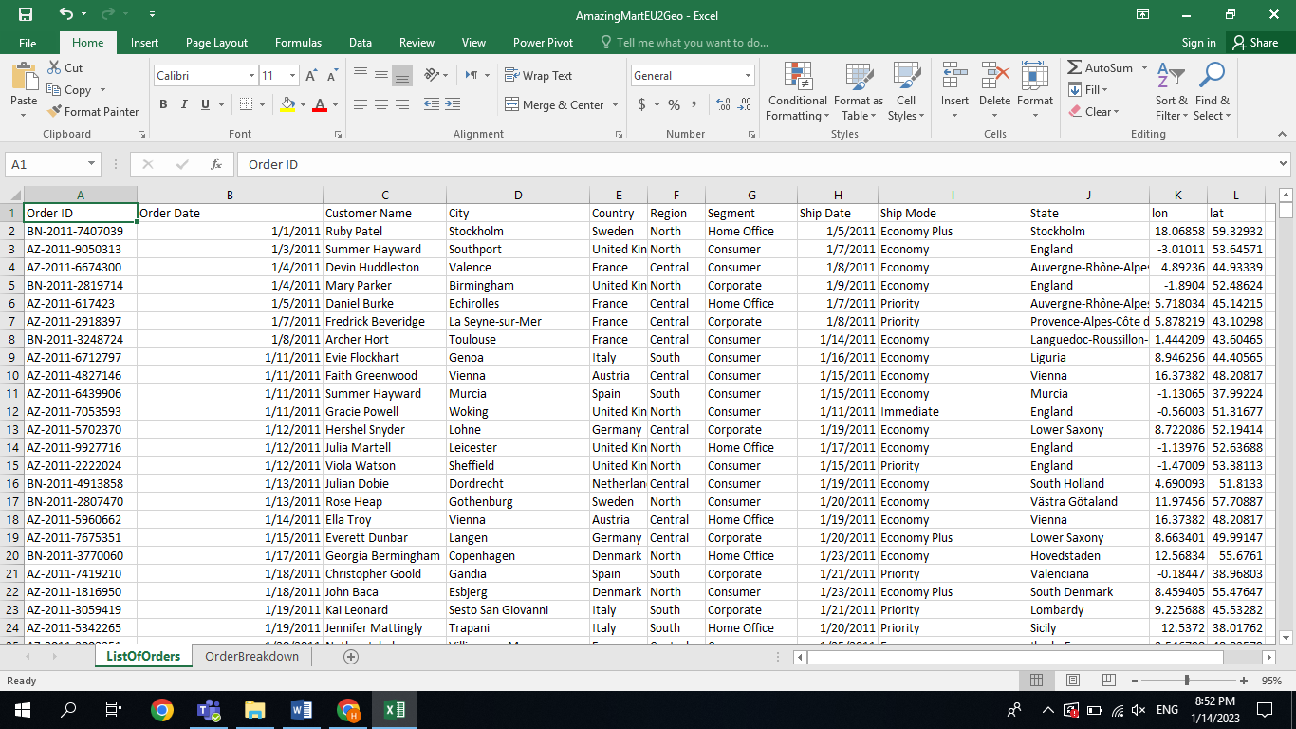  
Figure 1

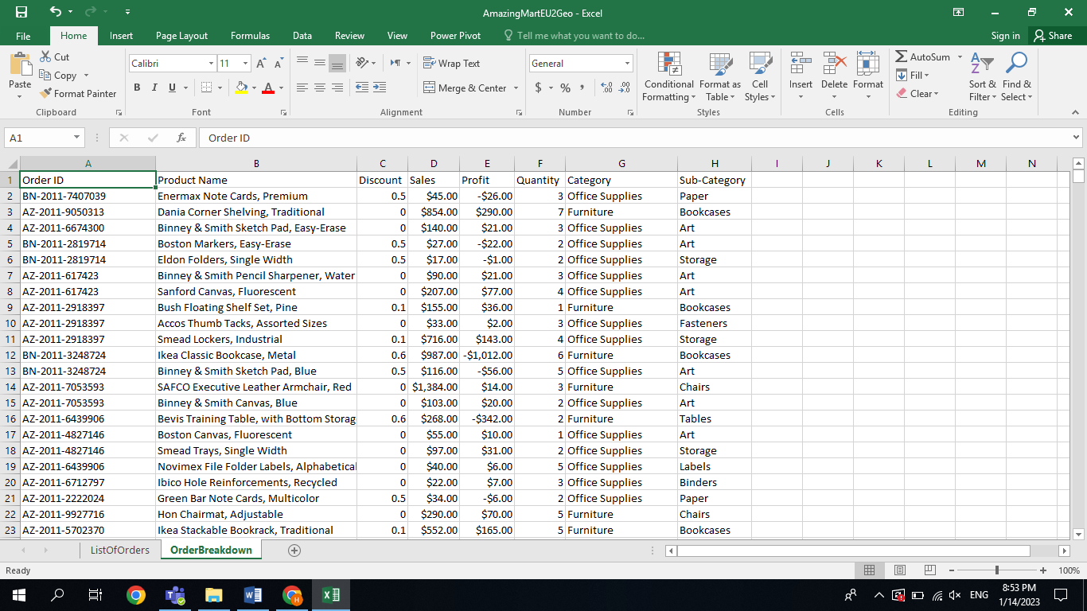  
Figure 2

## Requirements

-Total profit, cost, and sales for all orders.

-profit margin.

-Sales by (country, year, quarter, month, category, segment, ship mode).

-Total number of customers even in each different category.

--Sub-category which has the highest (sales, profit, quantity).

-Profit by (sub-category, segment).

-Quantity by (segment).

-Profit and discounts by month.

-Top 5 product with highest sales.

-Count of category and sub-category by ship mode.

-Count of product by category.

# Solution

## Tools

With Business Analytics tools, we can have a more profound understanding of primary and secondary data emerging from the activities. This helps businesses refine their procedures further and be more productive.  
tools such as (Power BI , Tableau , Qlik sense, Looker ,Domo , etc..)

1. Microsoft power BI

Power BI is a technology-driven business intelligence tool provided by Microsoft for analyzing and visualizing raw data to present actionable information. It combines business analytics, data visualization, and best practices that help an organization to make data-driven decisions.

## Components

## Dashboards:

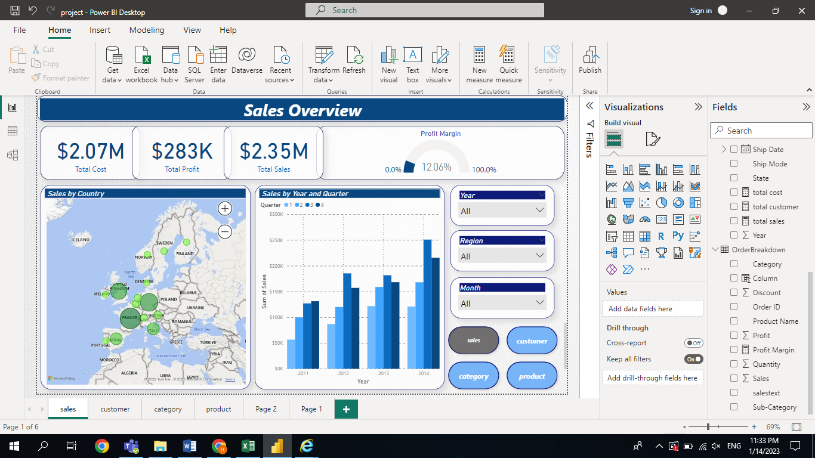

Figure 3

Three cards show the total profit, total sales, total cost and profit margin, map shows sales by each country, and clustered column chart shows the sales by year and quarter. All these visuals are filtered by year, region and month beside the navigation.

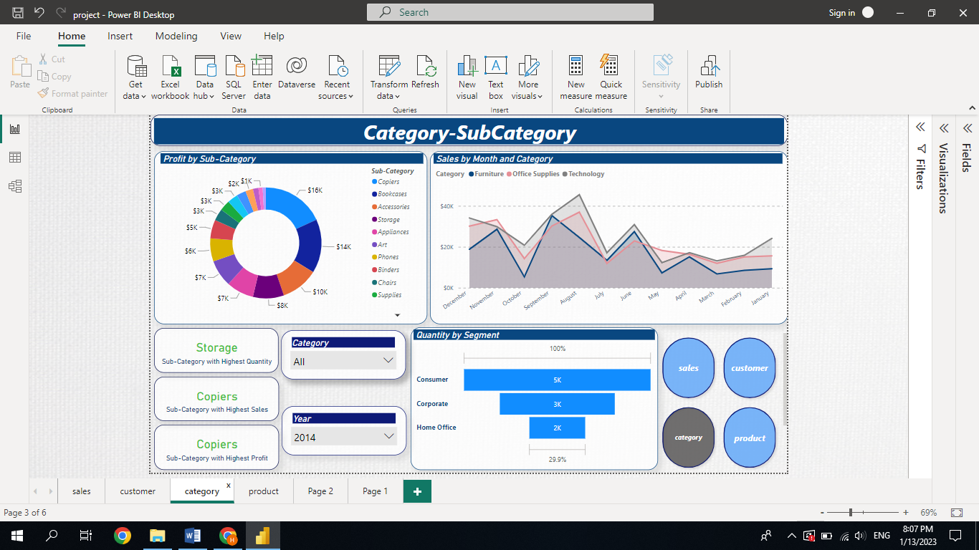  
Figure 4

Three cards show the three sub-category with highest sales, profit and quantity, area chart shows sales by month and category, donut chart shows the profit by sub-category, and funnel shows quantity by segment. All these visuals are filtered by year and category, beside the navigation.

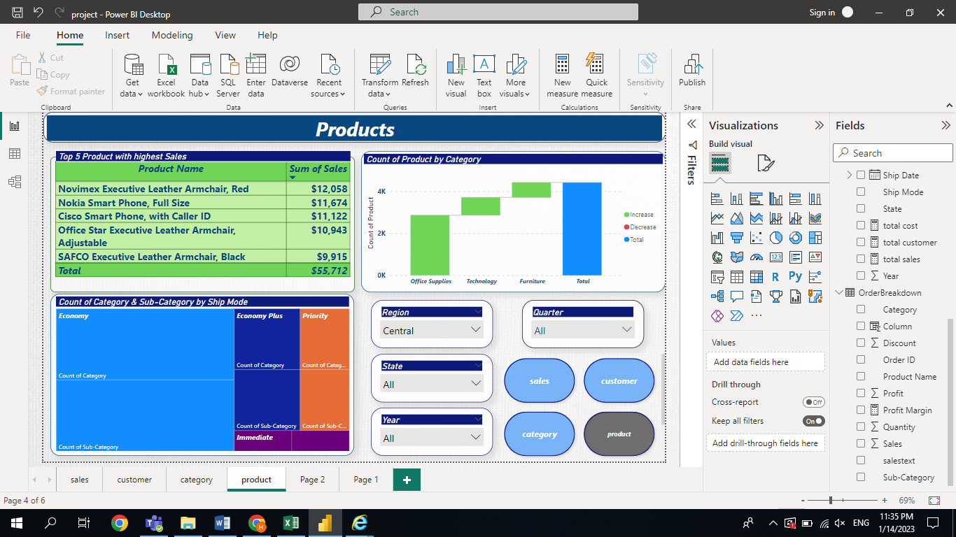  
Figure 5

Table show top 5 product with highest sales, waterfall chart shows count of product by category, and treemap show count of category and sub-category by ship mode. All these visuals are filtered by region, state, quarter and year, beside the navigation.

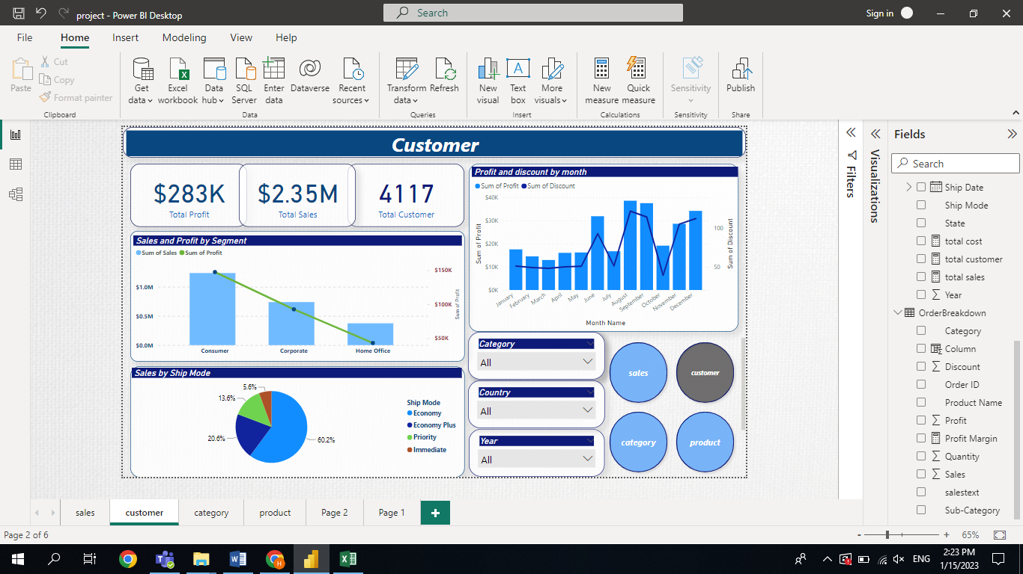  
Figure 6

Three cards show the total profit, total sales, total customer, pie chart shows sales by ship mode, line and clustered column chart shows sales and profit by segment, and line and clustered column chart shows profit and discounts by month All these visuals are filtered by year , country and category beside the navigation.

# Conclusion

In conclusion, this sales report shows different visual with different data that will help ensure the user has the necessary information to understand and interpret the data also to able decision makers to see the solutions on the front of their eyes by highlight the important data in analyzing way and finally to get more revenue.

## 3.1 Recommendations

1. Focus on consumer segment which give the highest sales over the 4 years.
2. The organization must offer special discounts in October, May and June as sales are at their lowest.
3. France and Germany which are located in the center of the region must take special attention where sales are at their highest.
4. Economy ship mode is give the highest sales with (62.25%) of total sales.

# **References**

* <https://www.coursera.org/articles/data-analytics>
* [Google Data Analytics Professional Certificate | Coursera](https://www.coursera.org/professional-certificates/google-data-analytics?utm_source=gg&utm_medium=sem&utm_campaign=15-GoogleDataAnalytics-ROW&utm_content=B2C&campaignid=12566515400&adgroupid=117869292925&device=c&keyword=how%20to%20become%20a%20data%20analyst&matchtype=b&network=g&devicemodel=&adpostion=&creativeid=507290840618&hide_mobile_promo&gclid=CjwKCAiAwomeBhBWEiwAM43YIPGcOyojg1L_gba7XkkBzFiSYuYjJNc0P8CRsZQlCuNTavUmZtuXxhoC4eEQAvD_BwE)
* <https://help.salesforce.com/s/articleView?id=sf.bi_integrate_dataset_columns_and_rows.htm&type=5>
* <https://github.com/pavanjuturu/Tableau>
* <https://www.simplilearn.com/tutorials/power-bi-tutorial/what-is-power-bi#:~:text=Power%20BI%20is%20a%20technology,to%20make%20data%2Ddriven%20decisions.>